**13.USING RAPTOR –CALCULATE FIBONACCI SERIES**

**Y.NAVEEN KUMARREDDY**

**192111405**

**FLOWCHART:**

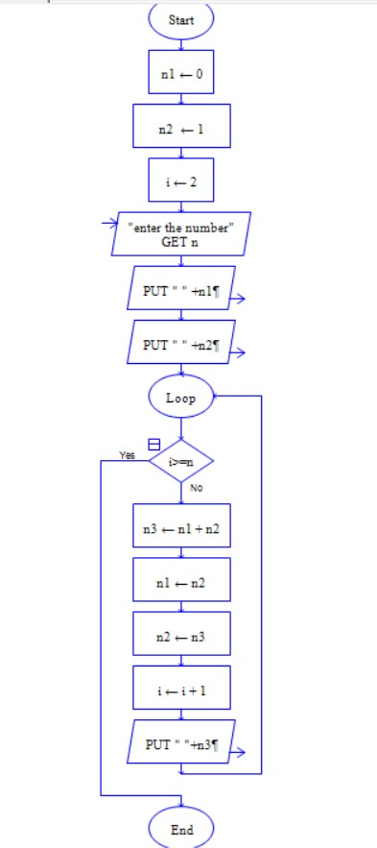

**OUTPUT:**

INPUT: 10

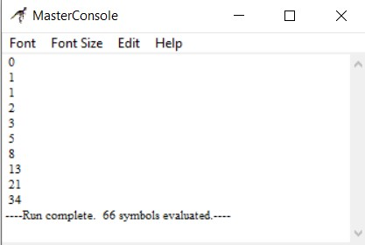

**RESULT:**

The program is executed and verified successfully.